**Terrain setup and how to use DEM calculations in SEAMCAT simulation**

Version Control

|  |  |  |
| --- | --- | --- |
| **Doc.Ver.** | **Date** | **Changes** |
| *V1* | 28/3/22 | First description of terrain features implementation in SEAMCAT v. 5.4.3 A4 |
| *V2* | 28/4/22 | Review and explanation of new features in v 5.5.0 A1 (introduction terrain calculations in SEAMCAT simulation, terrain settings in configuration, expanding terrain features in tools) |
| *V3* | 3/11/22 | Review and introduction of explanation of new features in v 5.5.0 A2 (new terrain formats and propagation models supported, workspace terrain settings, EPPs extracting terrain data) |
| *V4* | 28/2/23 | Review and explanation of new features in 5.5.0 A3, set up Terrain Settings for the Workspace |
| *V4* | 28/6/23 | Review and explanation of new features in 5.5.0 A4, adding information on new terrain formats and reader available, adding info on downloading ASTER GeoTIFF data, information on new PMP supported and multiple PMP functionality |
| *V5* | 22/11/23 | Review and explanation of features in 5.5.0, editing or the text |

Document content:

1. Pre-requisites
2. How to setup system and simulation using digital terrain in SEAMCAT and run simulations
3. How to inspect results of simulation using digital terrain in SEAMCAT
4. How to use Terrain profile Tool
5. How to use Propagation Model Test Tool
6. How to use EPP 15 to extract terrain data of simulation using digital terrain in SEAMCAT
7. How to use EPP 1 to extract Geo coordinates and propagation loss of simulation using digital terrain in SEAMCAT
8. How to download SRTM files on website <https://earthexplorer.usgs.gov´>
9. Where to find and how to download ASTER GeoTIFF files
10. Note on void filling method in SEAMCAT
11. **Pre-requisites**

* Download / installation of SEAMCAT version supporting DEM / SEM (5.4.3A4 or later)
* SEAMCAT terrain reader supports:
  + SRTM 1-Arc second (30 m) version 2 and version 3 in bil format
  + SRTM 3-Arc second (90m) version 2 raster data in bil format
  + SRTM 1-Arc second (30 m) version 3 GeoTIFF in tif format
  + ASTER GeoTIFF in tif format
  + Other GeoTIFF formats ending with dem.tif, 1arc_v3.tif
* Terrain tiles needed for the area of interest have to be downloaded (e.g. using USGS earth explorer, or elsewhere – see information on acquiring the data bellow) and put in Folder reachable to SEAMCAT (could be also on cloud)

1. **How to setup system and simulation using digital terrain in SEAMCAT and run simulations**

* Note: Interference simulation using DEM are computationally heavy and can result in longer simulation time (please take care of that when determining No of links, Terrain step size, No of events in simulation, No of tiers considered in cellular systems, etc. )
* Setup general Terrain settings in SEAMCAT Configuration (File / Configuration)
  + Define Data format used
  + Define File path to the DEM / SEM data (path to bil or tif files)
  + Note – these configuration settings are saved so need to do that only first time running DEM, these settings are used for new workspaces, or loading older workspaces which do not contain terrain settings

* Set up Systems & Scenario settings as defined in SEAMCAT Handbook (no change)
* Set up Terrain Settings for the Workspace using terrain calculations (this settings can be different than in configuration and those will be used for the simulation)

* You can setup calculations using digital terrain for all 3 types of links (works on generic and cellular system types):
  + Victim system link (Set up in Systems / Positioning and Propagation)
  + Interfering system link (Set up in Systems / Positioning and Propagation)
  + Interfering link (Interfering system Transmitter to Victim system Receiver) (Set up in Scenario – Propagation model)
* Select PMP supporting calculations with DEM / SEM (ITU-R P.456-16, ITU-R P.456-17, ITU-R P. 2001-4, and ITU-R P.1546-6 available) for the link of your choice (VSL, ISLs, ILs)
  + Select Use Terrain profile data Check box (to have terrain calculations for that link in simulation)
  + Setting multiple PMP per link is possible from v5.5.0 A4, some of link sections could be with terrain PMP

* Define Scenario Terrain settings in the Scenario Tab
  + Define Geographical coordinates of the reference point of the Victim system (Coordinates are Latitude / Longitude in the decimal degrees format, N and E hemisphere are with +)
  + Define step size for calculation of terrain profile
  + Define if reference coordinate point to VLT, or VLR for Generic, or Victim BS ref cell for cellular
  + Note: Coordinates of all other points in SEAMCAT run are determined by System / scenario settings and generated in simulation in SEAMCAT cartesian coordinate system and then calculated to Geo coordinates using refence point coordinate
  + Note: Setting smaller step size makes simulation more time consuming
  + Note: 1 arc second DEM source data is approximately 30 meter raster

* Run SEAMCAT simulation

1. **How to inspect results of simulation using digital terrain in SEAMCAT**

* For the links specified to use digital terrain - SEAMCAT simulation is run extracting digital terrain profiles from DEM / SEM and calculating propagation loss and corresponding received signals (dRSS, iRSSu, iRSSb) using digital terrain
* You can inspect details of the terrain profile, Tx & Rx Geo coordinates, intermediate values, angles, coordinates, and calculated results in the Results / Event results tab;
* Note: terrain profile for the selected link can be seen in the Side view in the Results / Event results tab;
* Use EPP 15 and EPP 1 to inspect and extract additional terrain data;

1. **How to use Terrain profile Tool**

* Select Terrain Profile Tool from the Tools menu
* Set up Positions and Heights of the Tx and Rx points of the profile
* Set up Frequency and Step size
* Set up propagation model specific parameters
* Settings

* Results
  + Note Result data – path profile, and propagation loss along path can be exported to file

1. **How to use Propagation Model Test Tool**

* Select propagation models to test
* Set up propagation model specific settings
* For propagation model using terrain select check box Use Terrain Profile Data
* Set up Control panel settings
  + For Terrain – select Terrain Settings and there Select Start Geo coordinate, raster and Azimuth in deg

* Inspect results – See below comparison of Free space, ITU-R P.452-16 with and without terrain

1. **How to use EPP 15 to extract terrain data of simulation using digital terrain in SEAMCAT**

EPP 15 enable SEAMCAT to collect geographic coordinates of Tx and Rx, calculated basic transmission loss and terrain profile. These values are collected for last event for all links in the simulation event: Victim system links, Interfering system links and Interfering links and exported to files.

Collected values are:

* Frequency (MHz)
* Distance (km)
* Pathloss (dB)
* Tx Latitude and Longitude (degree)
* Rx Latitude and Longitude (degree)
* Terrain profiles (m / km)

EPP 15 user interface:

UI gives explanation of values collected and enables user to determine for which category of links in SEAMCAT simulation wishes to collect values. UI is consistent with settings used for some other EPPs (e.g. EPP 1, EPP11, etc.).

EPP 15 Results:

EPP15 results are available in the Results section grouped by type of the link

By clicking link type group, user gets detailed results of collected values giving type of value and unique identifier of link (same as in Event results display). Here is example of values collected for generic system victim system link

When selecting Terrain profiles section for selected type of link user get all terrain profiles and can select terrain profile of interest to get display of height – distance profile and can export it in external file.

1. **How to use EPP 1 to extract Geo coordinates and propagation loss of simulation using digital terrain in SEAMCAT**

* EPP1 can be added to simulation and used for collecting or inspecting some of the intermediate results like geo positions and path loss calculated in the simulation
* In the EPP 1 settings you need to select for which type of link to collect values

* Results are available under Results

* Below you can find some examples of use of the EPP1 results
* In Results section you can inspect these collected values by type of the link

* Compare vector tool can be used to compare vectors (e.g. propagation loss for different links)

* Vector scatter tool can be used to inspect scatter plot of the positions of the points in the Geo coordinates

1. **How to download SRTM files on website** [**https://earthexplorer.usgs.gov**](https://earthexplorer.usgs.gov)

* Create new account - Register profile

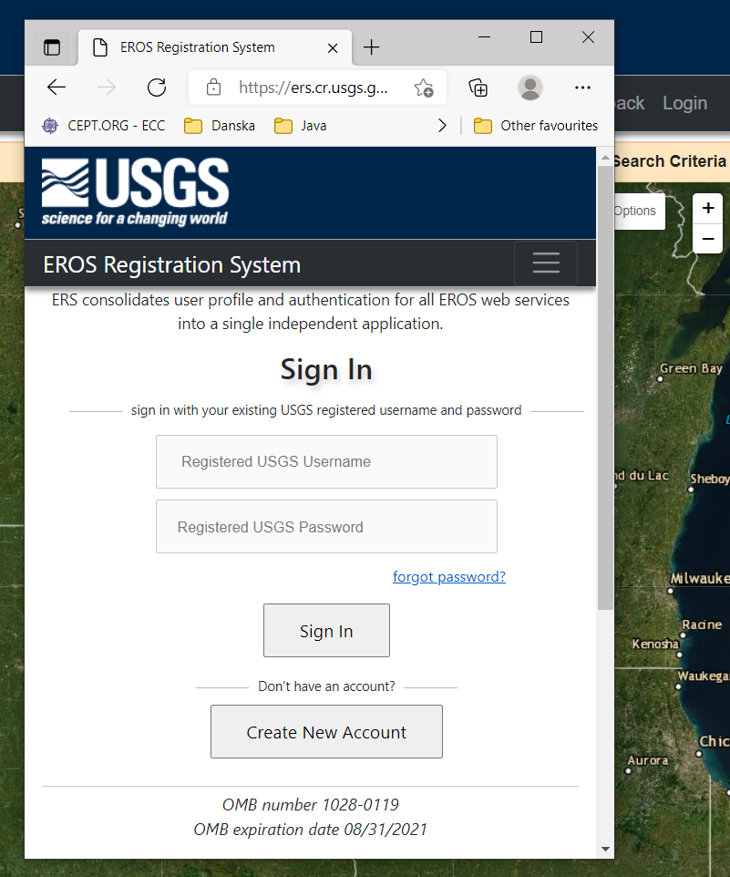

How to find and download files in EarthExplorer

* In EarthExplorer Zoom map on the area of interest for DEM files download
* Under first tab – Search Criteria – select Polygon and Use Map

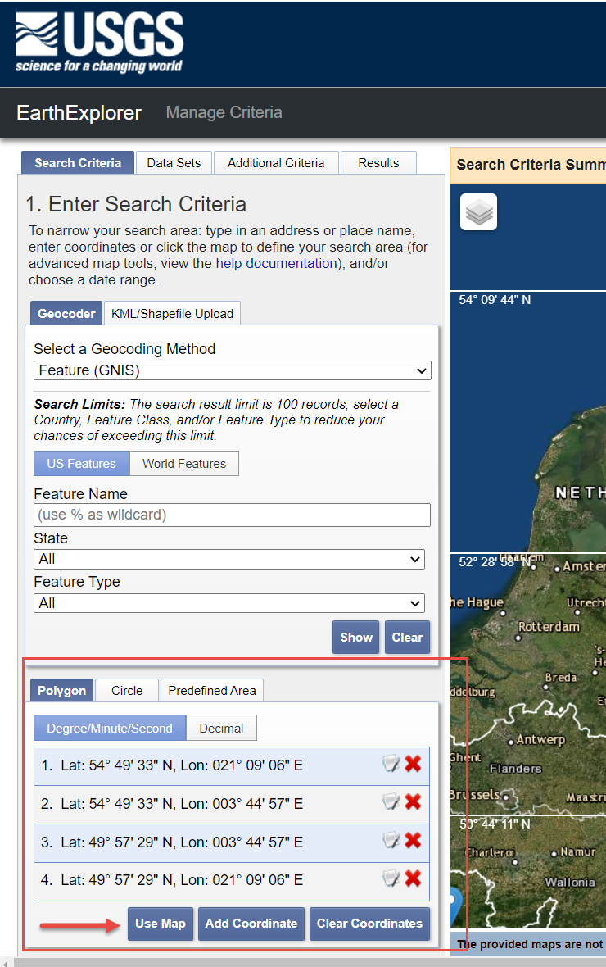

* Under DataSets Tab select Digital Elevation – SRTM – SRTM 1 Arc-Second Global
* Click Results to get resulting list

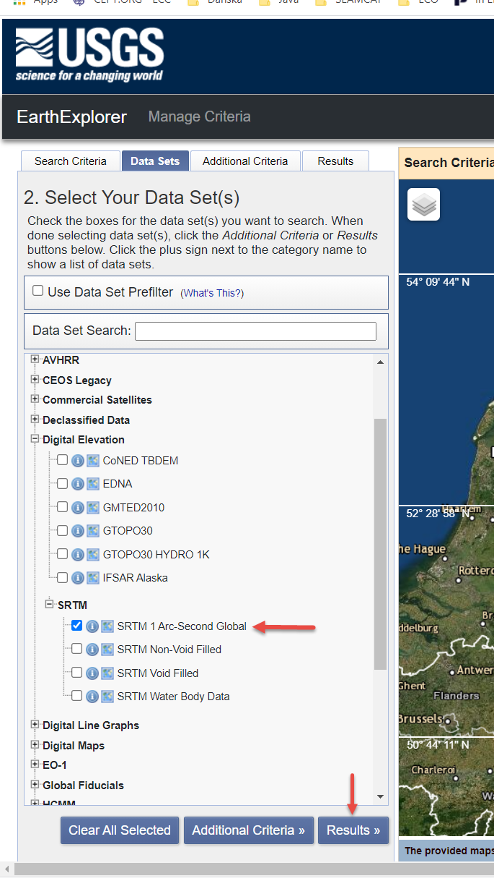

* In the Results tab select file you want to download

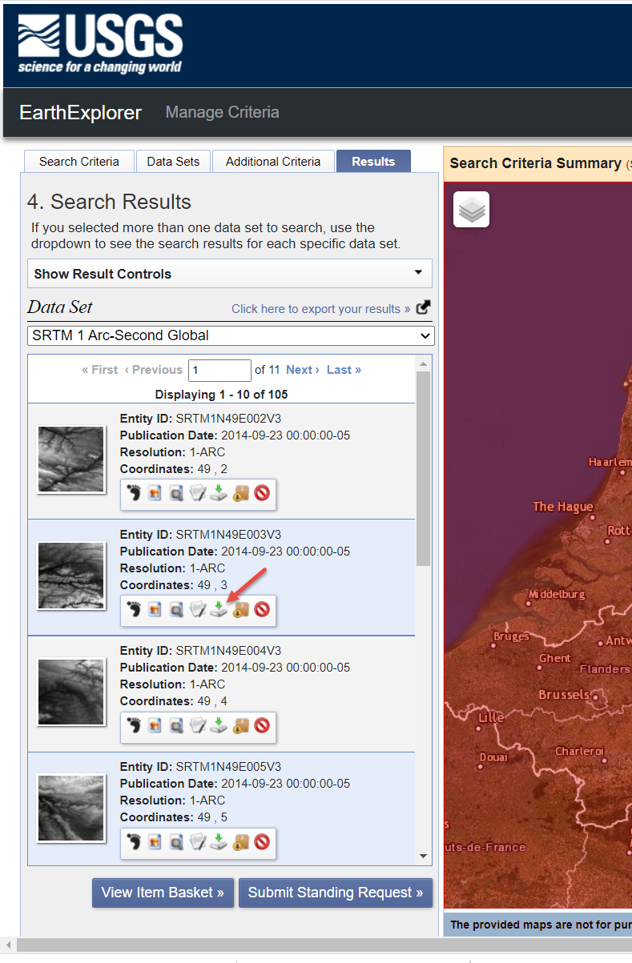

* For download select bil type of file

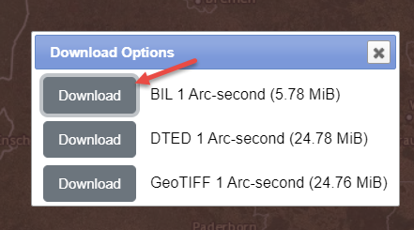

* There is option for bulk download of many files, but it downloads not just bil but other formats

<https://www.usgs.gov/centers/eros/science/usgs-eros-archive-digital-elevation-shuttle-radar-topography-mission-srtm-1-arc?qt-science_center_objects=0#qt-science_center_objects>

Definition of files naming and format:

<https://lta.cr.usgs.gov/DD/srtm.html#entity_id>

**Entity ID**

* *Field Definition:*  This field describes the naming convention of each tile.

Format:

SRTM3N35E089V1

SRTM = Dataset designator

1 or 3 (1 = 1 arc-second coverage, 3 = 3 arc-second global coverage)

N or S (N = North, S = South hemisphere)

Next two characters indicate lower left corner Latitude

E or W (E = East, W = West hemisphere)

Next three characters indicate lower left corner Longitude

V1, 2, or 3 (1 = SRTM Non-Void Filled, 2 = SRTM Void Filled, 3 = 1 Arc-Second Global)

1. **Where to find and how to download ASTER GeoTIFF files**

ASTER files are provided in GeoTiff format and only available for 1 Arc-Sec resolution (30 m). ASTER stands for Advanced Spaceborne Thermal Emission and Reflection Radiometer done by the Ministry of Economy, Trade, and Industry (METI) of Japan and the United States National Aeronautics and Space Administration (NASA).

**Aster data tiles can be found here:**

NASA provides a tool EarthData Search, with the help of which maps in ASTER Global Digital Elevation Model V003 (1 Arc-Sec, 30 m resolution) can be downloaded. A registration is necessary to open an EarthData account, but the “EOSDIS data are openly available to all and free of charge except where governed by international agreements.”

Link to [EarthData](https://search.earthdata.nasa.gov/search?gdf=GeoTIFF) Web site

Another tool that provides ASTER GDEM freely and without a need for registration is from the Japan Space Systems web page (also only Model V003).

Note: When downloading files from Japan Space Systems ASTER GDEM there will be 2 subfolders with different files – GeoTIFF DEM fiels are the files ending with dem.tif

Link to [ASTER GDEM](https://gdemdl.aster.jspacesystems.or.jp/) Web Site

**Format of file name:**

**ASTGTMV003_XXXXXXX_dem.tif**

* *Field Definition:*  This field describes the naming convention of each tile.

Format:

ASTGTMV003_N45E015_dem.tif

ASTGTM = Dataset designator

V003 = version of source data

N or S (N = North, S = South hemisphere)

Next two characters indicate lower left corner Latitude

E or W (E = East, W = West hemisphere)

Next three characters indicate lower left corner Longitude

dem = designation for DEM data

**Explanation of the format:**

* Geospatial World, “GeoTIFF – A standard image file format for GIS applications,” Online:

<https://www.geospatialworld.net/article/geotiff-a-standard-image-file-format-for-gis-applications/>

* NASA Earth Data, “GeoTIFF File Format,” 'Online:

<https://cdn.earthdata.nasa.gov/conduit/upload/12430/ESDS-RFC-040v1.1.pdf>

* Open Geospatial Consortium, “OGC GeoTIFF standard,” 2019, Online:

<http://docs.opengeospatial.org/is/19-008r4/19-008r4.html>

* Adobe, “TIFF,” Revision 6, 1992. Online:

<https://www.adobe.io/content/dam/udp/en/open/standards/tiff/TIFF6.pdf>

* Aware Systems, «TIFF File Format,» Online:

<https://www.awaresystems.be/imaging/tiff.html>

1. **Note on void filling method in SEAMCAT**

Global SRTM 1-Aec Sec data are not void filled in regions outside the United States. In that respect some tiles contain voids where height data is not defined[1].

According to the US Geological Society[2],

*“SRTM Void Filled elevation data are the result of additional processing to address areas of missing data or voids in the SRTM Non-Void Filled collection. The voids occur in areas where the initial processing did not meet quality specifications. Since SRTM data are one of the most widely used elevation data sources, the NGA filled the voids using interpolation algorithms in conjunction with other sources of elevation data. The resolution for SRTM Void Filled data is 1 arc-second for the United States and 3 arc-seconds for global coverage.”*

Voids shown with red colour in one tile

To avoid presenting voids in the extracted profile, SEAMCAT uses method to fill the void data in the profile with the last “valid height”. Note is added to the Terrain profile tool and PMP explaining this method.

1. It is observed that voids in general occurs in mountainous areas where there are big changes in height in short distance or water surfaces.
2. [USGS EROS Archive - Digital Elevation - Shuttle Radar Topography Mission (SRTM) 1 Arc-Second Global | U.S. Geological Survey](https://www.usgs.gov/centers/eros/science/usgs-eros-archive-digital-elevation-shuttle-radar-topography-mission-srtm-1#overview)